SAMPLE CALCULATIONS

Next steps:
- Include a reflection in the comment section of this assignment and copy to your Learning Portfolio.
- Give yourself a mark out of 20 (lots of calculations, so 20 gives a little more flexibility in deciding how you did) after you review the sample calculations & feedback below.
- Describe at least one aspect you understand well (WHAT you understand, do not just say “I understand percent composition” as this doesn’t show any knowledge, perhaps describe exactly where changed in the mass occurred during the lab and how this relates to your values calculated)
- Describe one area you can improve on or something that started confusing but you understand now.

Use this document to compare HOW you did your calculations. Your numbers should be in the same range for the experimental data and some questions should be exactly the same as they are from the periodic table.

All calculations should be neatly done, easy to follow, have appropriate units and try to use your significant figures knowledge!

Data Table:
 | Trial 1 | Trial 2 | Trial 3
- Mass of beaker, vinegar, and weighing dish (g) | 212.04 | 244.9 | 211.5
b) Mass of beaker, weighing dish, vinegar, and sodium bicarbonate (g) | 213.91 | 246.4 | 212.9
c) Mass of sodium bicarbonate (g) | 1.51 | 1.5 | 1.4
d) Mass of beaker, contents, and weighing dish after the reaction (g) | 213.31 | 245.8 | 212.5
e) Mass of carbon dioxide produced (g) | 0.60 | 0.6 | 0.4
f) Ratio of the mass of carbon to the mass of carbon dioxide | 0.27 | 0.27 | 0.27
g) Mass of carbon produced (g) | 0.16 | 0.16 | 0.11
h) Percent carbon in sodium bicarbonate sample | 10.6% | 10.7% | 7.85%

Post-Lab Questions:
- Subtract the combined mass of the weighing dish, beaker, and contents after the reaction from the combined mass of the beaker, weighing dish, contents before the reaction to find the mass of carbon dioxide lost to the atmosphere (row b - row d) . Record in the Data Table (row e).
Your numbers should be in the same range.
Trial 1: 213.91g - 213.31g = 0.60g | Trial 2: 246.4g - 245.8g = 0.6g | Trial 3: 212.9g - 212.5g = 0.4g

- Divide the atomic weight of carbon by the molecular weight of carbon dioxide to determine the ratio of the mass of carbon to the mass of carbon dioxide. Record ratio in the Data Table (row f).
Your calculations should match these exactly. The calculation is the same for all trials as this is not related to experimental data
% C = mass of C/mass of C0₂
=12.01amu /44.01amu
= 0.27% (you can represent this as a ratio or %. Same thing!)

- Multiply the mass of carbon dioxide by the mass ratio (row e • row f) to determine the mass of carbon produced in each trial. Record the results in the Data Table (row g).
Note: Depending on your experimental data, you may have slightly different masses of carbon from each trial. For this sample data, all trials produced 0.6g carbon. The percent or ratio of 0.27 is the SAME for all trials and comes from your calculation in #2 above.
Trial 1:  Mass C= 0.60 x 0.27(from step 2) above) = 0.16g | Trial 2:  Mass C=0.6 x 0.27 = 0.16g | Trial 3:  Mass C=0.60 x 0.27 = 0.11g

- Divide the mass of carbon produced by the mass of sodium bicarbonate to determine the percent carbon in sodium bicarbonate for each trial. Record the results in the Data Table. Calculate the average percent carbon in sodium bicarbonate.
Compare to the table above to see where these values come from and use those measured in your own lab.
Trial 1: (0.16 ÷ 1.51) x 100 = 10.6% | Trial 2: (0.16 ÷ 1.5) x 100 = 10.7% | Trial 3: (0.11 ÷ 1.4) x 100 = 7.85%
Average Percent = (10.6% + 10.7% + 7.85%) ÷ 3 = 9.7%

- Divide the atomic weight of carbon by the molecular weight of sodium bicarbonate and multiply by 100% to determine the theoretical mass percent of carbon in sodium bicarbonate.
Your calculation should be identical as these values are from the periodic table.
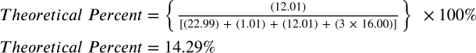

- Compare the average experimental mass of carbon in sodium bicarbonate to the theoretical mass and calculate the percent error.
Note: The straight horizontal bars on the numerator calculation indicate that after completing the subtraction you use the POSITIVE value in the division (so if you do the numerator subtraction and get “-5g”, you change it to positive 5g for the division.
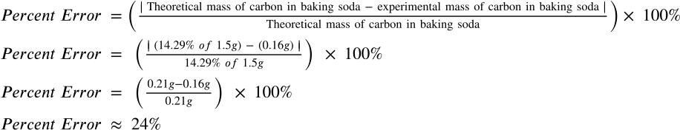

Your percent error may be higher or lower but it should be a positive value (no such thing as a negative percent error). Consider an explanation, based on what you observed and did in the lab, for your percent error. Did you measure too little mass somewhere? Not get a complete reaction for all possible CO₂ to leave the beaker? etc

